Networking Basics continued
ip addr show --info on all interfaces
ip -s link show eno1 --- get packet stats on an int. Int now not like eth0 but (more like bsd?) dependent on HW

/etc/sysconfig/network-scripts
Recommended: check out scripts in /etc/sysconfig/network-scripts/ifcfg-*
They are fairly readable and there is one for each connection/ interface

Hostname is in /etc/hostname
hostnamectl set-hostname vm0.example.com -- to set the hostname
hostnamectl status -- to request the hostname
DNS resolver is pushed from /etc/sysconfig/network-scripts/ifcfg-* to /etc/resolv.conf

IPv6
ip a -------lists... same as -a? ip link show
nmcli con add con-name blah type ethernet iframe eth0 ip6 2001:db8:0:10::d000:310/64 gw6 2001:db8:0:10::1 ipv4 192.168.1.5 gw4 192.168.1.1
Remember, new connections use IP4 or IP6 with NO "v" - modifying (using a "+") DOES use a "v":
nmcli con mod blah +ipv6.dns 2001:4860:4860::8888

Setting up routing
Rather than jump into ip route commands, this goes to nmtui
NMTUI opens with edit and activate (a connection) options and "set system hostname"

Routing - "edit a connection"
Under all of the standard IPv4 options is "Routing" with an edit hyperlink
It will say "no custom routes" and give you an "add" hyperlink
It asks for destination/prefix, next hop, and metric. click ok and exit
ip route show won't show it unless you reopen nmtui and click "activate connection"
It will show up in /etc/sysconfig/network-scripts/ When you open it, all it has is this:
ADDRESS0:10.0.0.0
NETMASK0:255.255.255.0
GATEWAY0: 192.168.4.4

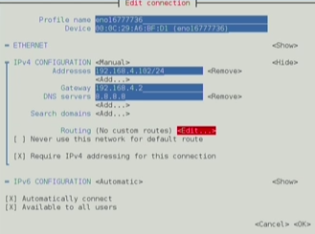
Virtual Bridges
eno1 to virbr0 bridges vnet0 and vnet1 virtual network interfaces, and each of those has one separate host attached
Remember that these "2 networks" are merely switched - the explanation made it sound like 2 subnets
These will be messing with vish constructs:
virsh list --all --get a list of the VM runnings
brctl show -- we see virbr0, whether stp is enabled, the bridgeid, the interfaces that are up
ip link show --baremetal lo and eno1 listed, and then virbr, vnet0 and vnet1
on the vnet0 and 1 these values are added: pfifo_fast master vibr0 state UNKNOWN mode default qlen 500
on virbr0, noqueue state UP mode DEFAULT
on eno1 - pfifo_fast state UP mode DEFAULT
All of these have the standard other stuff: <multicast, broadcast, up, lower_up>, mtu 1500 qdisk link/ether (mac address) brd ff:ff:ff:ff:ff:ff

The RHCE requirement is knowing how to set up a bridge
yum install -y bridge-utils --- You need to install this, and you have to know the current interfaces:
nmcli dev show -- Get the id of the interface, eno0166777723 for our ethernet
nmcli dev disconnect eno0166777723
nmcli con add type bridge-slave con-name br0-port1 ifname eno0166777723 master br0
-- do this to add the interface we disconnected to the bridge- It will complain the bridge isn't there, we make it below
-- you repeat this for the other interfaces that will be part of this bridge, br0
-- if you only have one interface, thats fine, two you can do load balancing etc for HP
nmcli con add type bridge con-name br0 ifname br0 -- defines the bridge
brctl show --will show your bridges
-- interesting to note, the bridge id is 8000.000000000000
Here is what we get when we check out the files in /etc/sysconfig/network-scripts/
Scared you won't remember these? Man pages! See nmcli-examples(5) page (is at the bottom of "man nmcli")
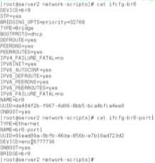
The nmcli-examples man page has everything you need to type, as long as you know what you are doing!!
TeamD
Network Link Aggregation - Bonding is deprecated. Teaming takes it's place.
Modes "runners": broadcast, roundrobin, activebackup (one line active, the other a backup), loadbalance, and LACP.

There are Four Steps to Network Teaming
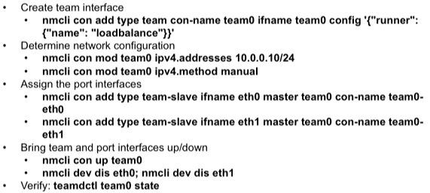
Note: Above, the order in "Assign port interfaces" is wrong (see example) con-name team0-eth0 goes before ifname!

Creating a Bridge Based on Network Teams
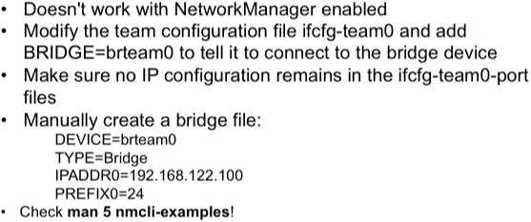

Command line example- complete teamd and link aggregation setup using teaming
